Assignment – Transformer Attention
Objective
This assignment is designed to help you understand the attention mechanism in Transformers, including the underlying math, intuition, and practical exploration with pretrained models (BERT & GPT-2).

Q1. Manual Attention Calculation
You are given:
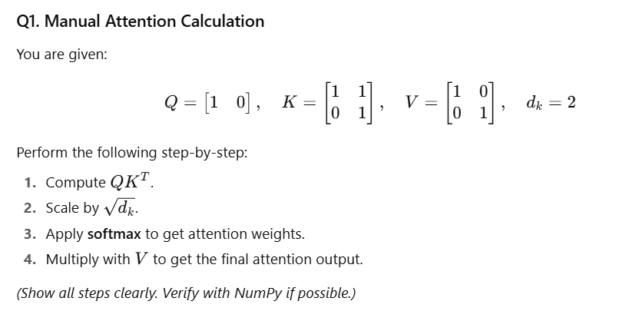
(Show all steps clearly. Verify with NumPy if possible.)

Q2. Softmax Behaviour
Consider scores = [10,0,−5].
Apply the softmax function manually (step-by-step).
- Which value dominates after softmax, and why?
- What does this tell you about why we need the scale factor 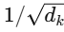​​ in attention?

Q3. Attention Intuition
Given the sentence:
“The dog chased the cat.”
- If Q=embedding of “dog”, which words should have high attention weights in K?
- Which words should have low attention weights?
- Briefly explain your reasoning.

Q4. Attention Weight Properties
State True/False with explanation:
- The rows of an attention weight matrix always sum to 1.
- If Q and K are identical, the attention weights will always be uniform.
- Multi-head attention simply repeats the same attention mechanism multiple times.

Q5. Toy Example – Polysemy
Sentence 1: “He went to the bank to deposit money.”
Sentence 2: “He sat on the bank of the river.”
- For each sentence, which words would you expect to have high attention weights for the word “bank”?
- How does multi-head attention help the model handle this difference in meaning?

Q6. Positional Encoding Concept
- Why do we need positional encoding in Transformers?
- What would happen if we removed positional encoding completely?

Q7. Single-Head vs Multi-Head
- In your own words, explain one advantage of multi-head attention compared to single-head attention.
- Give a simple example where multiple heads would capture different patterns in a sentence.

Q8. Attention Matrix Properties

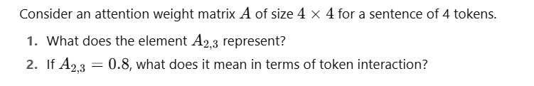

Q9. Coding Task – Getting Attentions from Pretrained Models
Sentence (S1):
"He went to the bank to deposit money."
- Using BERT (bert-base-uncased or distilbert-base-uncased), load the model with output_attentions=True.
  - Pass S1 through the model and print:
    - The number of layers of attention returned.
    - The shape of the attention tensor for the last layer.
- Repeat the same using GPT-2 (gpt2).
  - Again, print the number of layers and the shape of the last layer’s attention tensor.
(Tip: seq_len will depend on how the tokenizer splits the sentence.)

